The software include
1.”ads7871_v3s.exe” is the main program.
2.”CH341SER.exe” is the USB interface driver.
3.”ads7871_v3s.pre” is the file that saves the measurement conditions.
4.”ads7871_v3s.ini” is the configuration file, It saves the running parametera.
5.”Sample Script” folder contains examples of script measurements.
6. “sch” folder is the 2019 version of the full schematic

First Run
I. USB driver installation
Curve Tracer communication with PC using “USB to serial” , so you need to install the USB driver CH341SER.EXE (Windows 10 will auto install this drivers, or go to the chip manufacturer www.wch.cn download).
After installing the driver, connect the USB port of curve tracer to PC, a new serial port USB-SERIAL CH340 will appear in the list of system hardware devices, but not necessarily COM5, it may be COM3 or other ports, plugging different USB ports will produce different COM numbers.
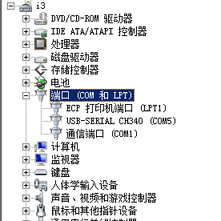
II. Software configuration
1. Communication COM port settings
After the ‘USB-SERIAL CH340” successful identification, running the main program “ads7871_v3s.exe”, but before you start measuring, you need to configure the software running parameters.
Select the main menu "Options" - "Config".
The system parameter setting window appears.
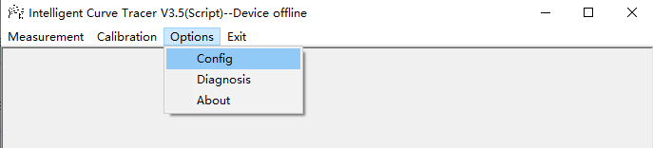
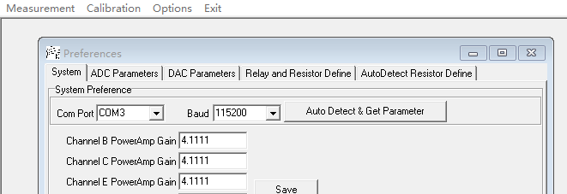
Click on the "Auto Detect & Get Parameters" button and the program will automatically search all serial ports.
If found, it will prompt "Parameter have get from Device", indicating that it is connected and the parameters have been loaded from the MCU. At the same time the Com Port and Baud drop down boxes will automatically change to the com port number and baud rate at this time. Then click 'Save' to save it so you don't have to search the serial port next time.
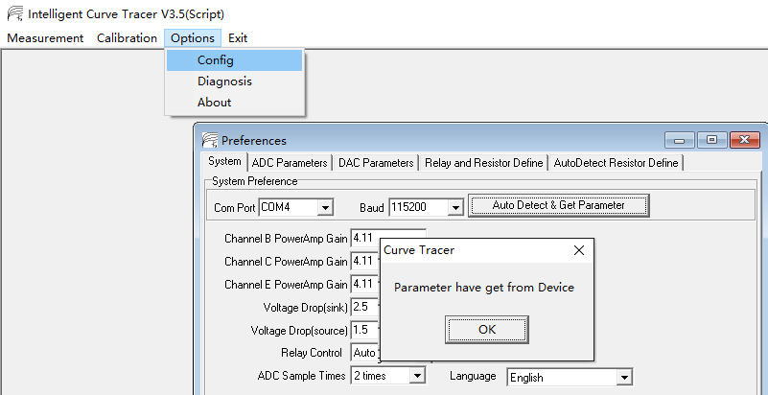
However, if you change the USB port, the COM port will change, so before you measure curve, you need to click 'Auto-detect &get parameters' again and save it to update the COM port setting.

- Output Voltage calibration
Menu “Calibration” ->”Voltage Calibration” -> sheet ”BCE Channel Voltage Adjustment”
Click ‘Begin Calibration”, and save.
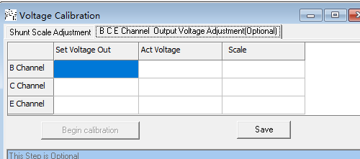
This step in order to calibrate B/C/E channel output amplifier gain.

- Constant Current calibration
Menu “Calibration” ->”Current Calibration” -> sheet ”Constant Current Calibration”
Use a wire short scoket B and C, and click button ‘calibration’,and “save”
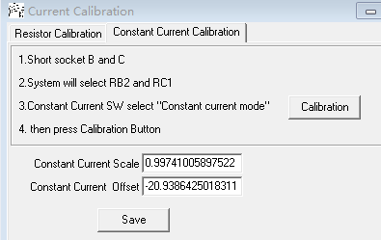
When finish step 2 and 3, the parameter will save in ads7871_v3s.ini file. So the ads7871_v3s.ini is only suit your curve tracer. If you change another set curve tracer, you need to re-do step 2 and 3.
- Measure the curve
Select menu ‘measurement->Curve Tracer’, then display the window
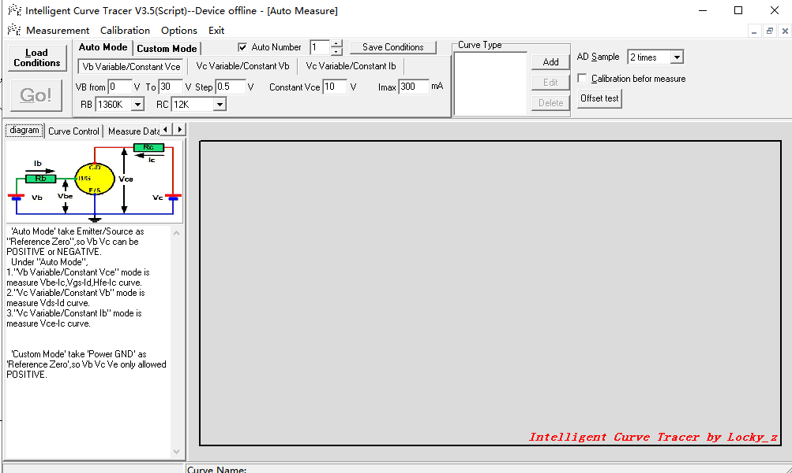
Click “Load Conditions’ button will display some ‘pre-define’ measure condition,
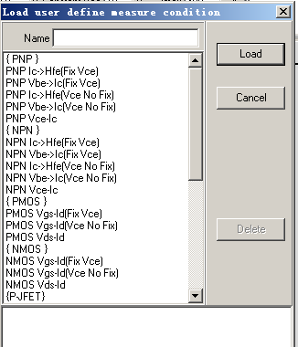
For example ,you want to test a 2sa970,it is a small signal PNP,then choice ‘PNP Ic-Hfe(Fix Vce)’,and click ‘Load’ button. The measure condition will load,
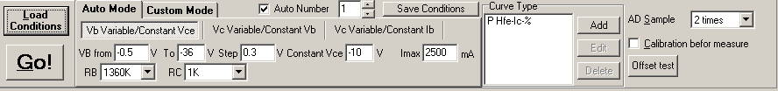
then you plug the 2sa970 into socket, Base plug into ‘B’, emitter plug into ‘E’,collect plug into ‘C’.
and then click button ‘Go!’,The Curve Tracer will begin measure and draw a ‘Ic->Hfe’ curve.
The curve’s X-Axis is ‘collect current(mA)’,Y-Axis is ‘Hfe’.
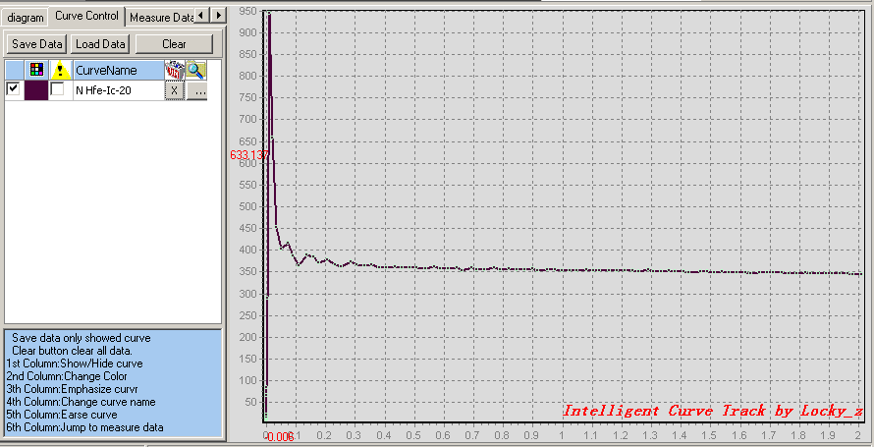
the result area split two part,Left is control area,Right is curve display area.
There are 6 column to control the curve display,
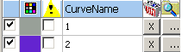
1st column is a ‘CheckBox’,checked it will display curve ,unchecked will hide the curve
2nd column is control the curve colors.double click the color bar can change the curve color.
3 th column is emphasize the curve,checked it will shine the curve.
4th column is change the curve name
5th column button is delete the curve
6th column button is jump to the curve measure data.

‘Save Data’ button to save all display curve to a single file(xxxx.cuv file).
‘Load Data’ is load the curves data from xxxx.cuv file.
‘Clear’ button is Clear all the data and curve..

‘Measure Data’ page,
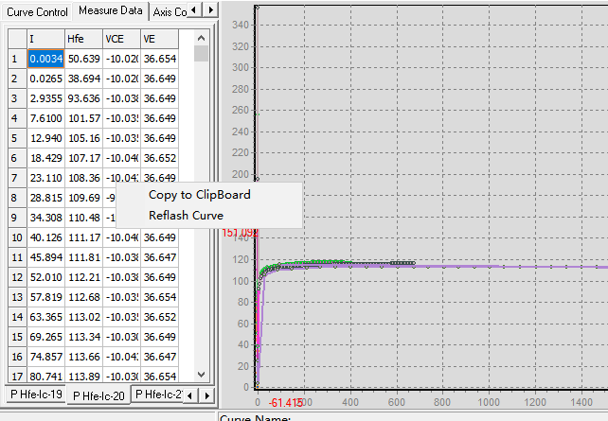
This table contain all curve’s measure data, A page corresponding to a curve,Curve name is page name.
You can direct modify the data. Double click the sequence number column can delete a row; after modify, you can right click mouse and select ‘Reflash curve’ to redraw the curve with new data; you can also copy the measure data to clipboard.

Curve display area.
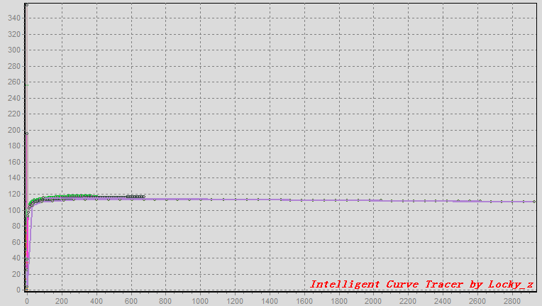

You can:
Move mouse over the curve, it will display the curve name in state bar,
Hold down ‘right mouse button’ to move the curve,
Hold down left mouse button to draw a ‘rectangle’ to zoom or do some calculate.
Double click anywhere will restore the zoom.
Right click anywhere can copy curve image to clipboard,or restore zoom or sort these curve
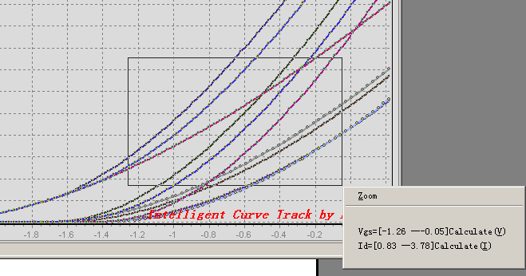

Components type, pin automatic recognition
Select menu ‘Measurement->DTU Auto Detect’,show the window
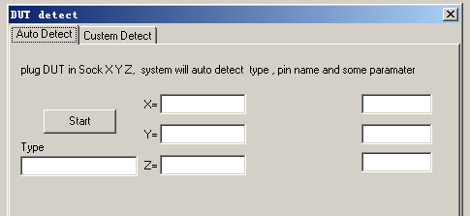
click ‘Start’ button, and plug DUT(device under test) in socket X Y Z
system will auto detect the Compnent type and pin name,
if is BJT will measure the Vbe Hfe and Ic
if is Resistor ,will show Resistance value
if is Diode ,will show Vf and current
if is FET will show Vgs and current and Vp(Pinch off voltage)

But the function may not accurate,becase it use MCU’s ADC,and only 5V measure ,the current is small.
If the DUT is damaged, it will mistakenly identify other types.
If the NPN (or PNP) also has a reverse hfe more then 20, it may not be able to accurately identify the emitter and collector.
Curve tracer advanced
1.Condition define panel
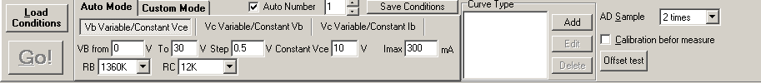
there two measure mode
“Auto Mode” is take Emitter/Source as "Reference Zero",so Vb Vc can be POSITIVE or NEGATIVE.
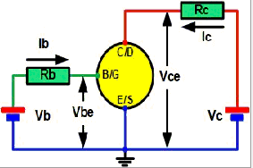
In fact,you set the negative voltage. System will automatic processing, and calculate and the facts unipolar Emitter/Base/Collect Channel Voltage.
Under "Auto Mode" have three sub mode:
1."Vb Variable/Constant Vce" mode is measure Vbe-Ic,Vgs-Id,Hfe-Ic curve.
2."Vc Variable/Constant Vb" mode is measure Vds-Id curve.
3."Vc Variable/Constant Ib" mode is measure Vce-Ic curve.

“Custom Mode” is take 'Power GND' as 'Reference Zero',so Vb Vc Ve only allowed POSITIVE.The principle please to reference ‘schematic.doc’
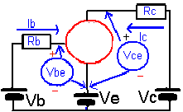
Under "Auto Mode" have three sub mode:
1."Vb Variable " mode is Ve and Vc constant, only Vb can step up/down.
2."Vc Variable" mode is Ve and Vb constant, only Vc can step up/down.
3."Ve Variable” mode is Vb and Vc constant, only Ve can step up/down..

The value control panel is:
Setup Variable Channel‘s start and end value,and step size
Setup the constant value.
Setup the maximum current(Imax)
Select B and C channel current sampling resistance(RB.RC).
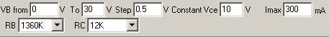

Add a incremental number to curve name.

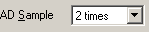 Control ADC Sampling times, The more Sampling then curve may more smooth and more precise but more time spend.

If check it,system will calibration before every measure a curve.

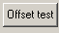 This button is used to see the effect of the voltage calibration, he will measure 4 curves, these 4 curves generally fluctuate around the X axis, the smaller the fluctuation the better. The maximum magnitude of the fluctuation reflects the error of the measured voltage.
If this ‘offset test’ is performed and the curve deviates from the X-axis by a large amount, e.g. by more than 0.01V, then check the "Calibration before measure" box and the system will recalibrate.

The frame is define curve what you want.(System will not measure if there are no any curve define in this frame)
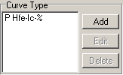
You can Add/Edit/Delete the curve.

Such as above ‘P Hfe-Ic-%’ curve define,you click ‘Edit’ Button ,you see the window:
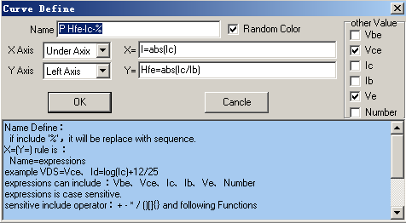
the ‘Name’ field is define Curve Name, the Symbol ‘%’ will replace with the incremental number automatic.
The ‘X Axis’ Dropdown box define ordinate axis show on Under or Above.
The ‘Y Axis’ Dropdown box define ordinate axis show on Left or Right.
The ‘X=’ field is a expression,It’s rule is:
any name = expression
the expression can include ‘Vbe/Vce/Ic/Ib/Ve/Number’ keyword.(System have five keyword ‘Vbe/Vce/Ic/Ib/Ve’ they are the actual measure value.The ‘Number’ keyword is measuring sequence number.)
the expression can include operator ‘+ - * / ()[]{}’, and some functions:
abs(x) / acos(x) / asin(x) / atan(x) / acot(x) / cos(x) / cosh(x) / cot(x) / exp(x) / floor(x) / mod(x,y) / ln(x) / log(x) / pow(x,y) / sin(x) / sinh(x) / sqrt(x) / tan(x) / tanh(x)
expressions is case sensitive.

For example:
VDS=Vce mean define a Variable:VDS,it’s value is actual measure ‘Vce’ voltage.
Example 2:
I=ln(abs(Ic)) mean define a Variable:I,It’s value is actual measure ‘Ic’ current’ absolute value and taking the logarithm.

define curve color,If check it ,system will use random color to show the curve.
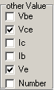 define additional data in Measure Data page table.

save you measure condition define.

Example use condition panel to test three-terminal regulator 7805 “Vi->Vo” curve tracer
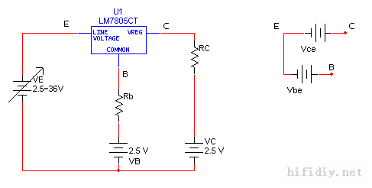
The current on 7805 common terminal is the smallest, The load current are flow through input and output pin, and the curve tracer only C & E channel can output large current, so the 7805 common terminal connect socket B; in fact, a RB = 500 ohm resistor are series to VB power source. Therefore, you can measure the voltage drop on RB can get 7805 quiescent current.
You also need to get the load current, so, connect 7805 output terminal to socket C,because socket C is series a resistor RC, which can measure the current. The 7805 Vin input is connected to the socket E.
Its equivalent measurement circuit is shown above Fig.

Since the 7805 common terminal is the lowest voltage, so set power source VB to 2.5V, Power source VC is also set to 2.5V, and Ve is set to step from 2.5V to 36V to produce a variable input voltage of Vi=0~33.5V. The measurement mode selected is therefore a "VE variable" custom measurement mode.
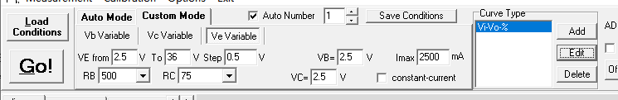

Now, how do you define X and Y axis?
Also see above Fig.
7805 input voltage Vi = point E voltage - point B voltage.
Output voltage Vo = point C voltage - point B voltage
And the system only provides the measured values Vbe, Vce, Ic, Ib, how to get Vi and Vo?
Actually “point B voltage - point E voltage” is Vbe. So Vi is “-Vbe”.
The "point C voltage - point B voltage" can refer the Fig on right, that is, Vo = Vce-Vbe, Vce, Vbe is polarized.
So the X-axis defined is Vi=-Vbe
Y-axis defined is Vo=Vce-Vbe
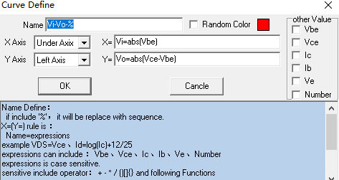
Here the purpose of adding abs() function is guaranteed to be positive.

Since the RC is only 4 resistance values, the current is also fixed. But from the Fig, it is known that the 7805 load current Io=(Vb+Vo-Vc)/RC (ignoring the voltage drop on Rb), changing Vb, Vc can achieve the purpose of changing the current. For example, if Vc is changed to 5V and RC=5 ohms, then the load current is about (2.5+5-5)/5=0.5A.

- Something about measurement conditions setting
- The most important thing about condition setting is to understand the "schematic"
- "Ic-Hfe"/"Vbe-Ic"/"Vgs-Id" curve has "fixed Vce" and "Vce not fixed" two types, all the semiconductor manual pdf is constant Vce/Vds(Fix Vce).
- The Ic-Hfe measurement conditions default are small current. It use RB=1360K and RC=1K to measure. So if measure larger current, change RB and RC range
On RB=1360K, the maximum base current is about Vcc - 4V / 1360K, it is about 0-26uA,
On RB=91K, the base current is 0-400uA,
On RB=6K, the base current is 0-6mA,
On RB=500, the base current is 0-70mA,
- Because the curve tracer minimum voltage resolution is about 2-10mV, so when measuring the current, it is best to make the drop voltage on the sampling resistance RC(RB) above 500mV to ensure the measurement accuracy.
So if select RC=5 ohm, It is recommended to measure minimum current is 0.5V / 5ohm = 0.1A.
RC=75 ohm , The minimum current is >6mA
RC=1K the minimum current is >0.5mA
RC=12K,the minimum current is >40uA
RB=500 the minimum current is >1mA
RB=6K the minimum current is >0.1mA
RB=91K the minimum current is >5uA
RB=1360 the minimum current is >0.4uA
I often hear user ask why I changed the range of the RC, but the Ic has not been big. Such below fig. He change RC to 75ohm or 5ohm, but the maximum Ic still is 2.3mA?
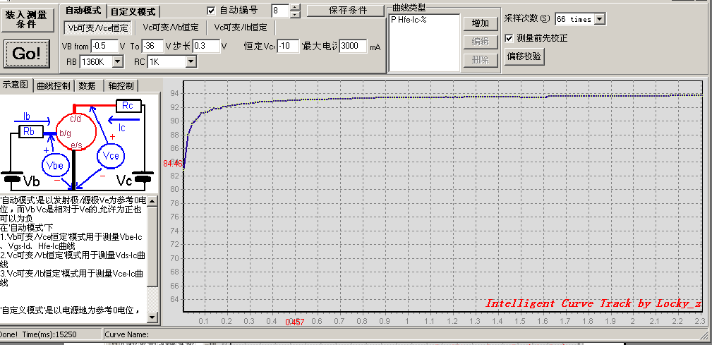The reason is he select RB=1360K, so the maximum base current is 26uA, and the BJT’s hfe is about 90, so the collect current is less 26*90=2.33mA.
- Generally, one curve have 50-70 point is fine. More point more time, and if under large current, more point will take more heat, it may destroy your component.
- When you test ”Ic-Hfe” curve ,the first or second point is far away curve. Such as below fig
Because at first, the Vb is step up from 0.5V, This voltage is so low that the resulting base current(Ib) is too small, the voltage drop on the RB/RC is too small, e.g. only 50mV, and the system resolution is only 2-10mV, i.e. the measurement is not accurate. Then use Ic divided by Ib, and the result is so large.So see that the beginning of the curve is way off.
The solution to this is to increase the start value so as to avoid the very small part of the current, for example by setting the VB start value from 2V.
- Measurement of MOS/JFET, gate for socket B, drain for socket C, source for socket E.
- measuring the P type component, still the base into socket B, the collector into socket C, and the emitter into socket E. You just need to load the appropriate type measurement conditions..
- When measuring MOS, because the program set B/C/E 3 channels in sequence, will cause an instant 36V add to Gate and Source, which may destroy some MOS. To be safe, it is best to connect a 15V voltage zener parallel between the socket B and scoket E.
- The "offset test" function is to detect whether there is a drift in the parameters, where VRB& VRC check represents the measurement error of Ib&Ic; Vbe&Vce check represents the measurement error of Vbe&Vce.
At its best, the average of the curves measured by the VRB/VRC/Vbe/Vce checksum should fluctuate around the 0 axis, preferably within 0.005V.
The above four corrections and temperature-related, for example, just turn on the power to verify good, but after a period of time to verify, the voltage will increase, you can checked the ‘Calibration before measure’ to solve it.
3.Measurement by Script
For example, the following script to measure the diode, the diode cathode connected C, negative connect E.
Select the menu “measurement ->script”, enter the following script, and then click "run script", you can get a diode VI curve.
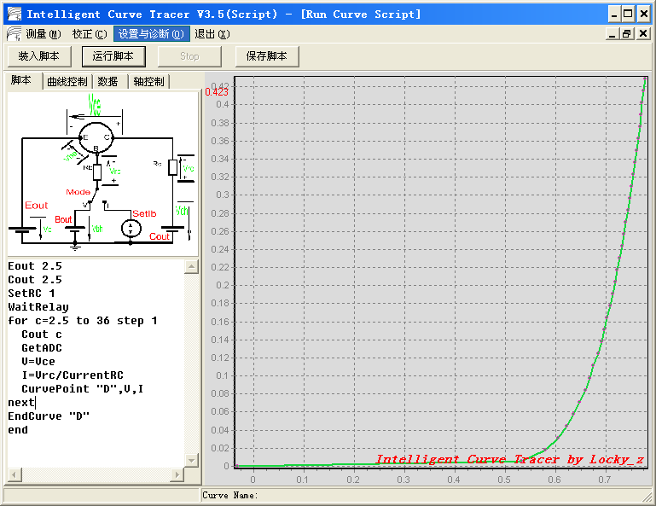
Before understand the script, We look at the system's control model first.
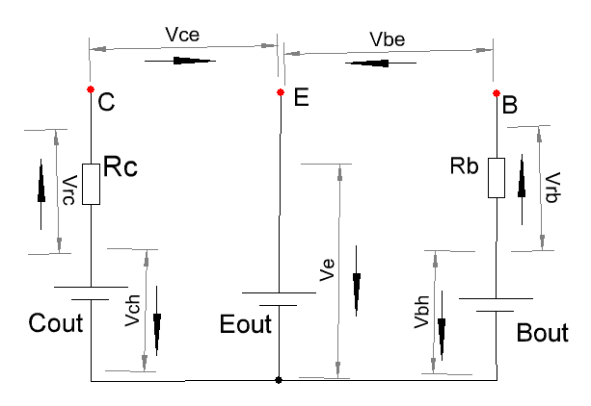
System has a 3 channel programmable voltage generator, they are the B, C, E channel amplifier.
And there are some resistor series with B/C channel output(RB and RC). System measure the voltage drop on the resistor to get the channel output current. But the E channel output no resistor.
The system, through the function “Cout/Bout/Eout” to Control B/C/E channel output voltage.

B/C channel series resistor each of which has 4 ranges.
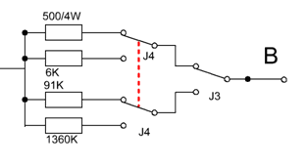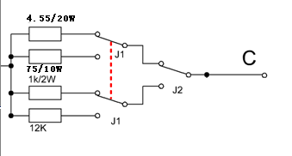
The RB resistance have 4 ranges,It typically is 500/6K/91K/1360K. The RC resistance also have 4 ranges,It typically is 5/75/1K/12K, function “SetRB/SetRC” used to select one of the 4 resistor.

For example, when the function "SetRB 0" is executed,, System control relay and select 500 Ohms series into the circuit, also system variables “CurrentRB” value will be set to 500.
Same to function “SetRC” is used to control the choice of RC range, and also affect system variables “CurrentRC” value.

System can measure 7 voltage,they are “Vch/Ve/Vbh/Vrc/Vrb/Vce/Vbe”. You can look at the system control model figure, They are bipolar, their polarity is indicated by the arrow label.

When script measuring the seven voltage, call function “GetADC”, The system will be carried out a A/D convertion, and measured those voltage and stored them in system variables “Vch/Ve/Vbh/Vrc/Vrb/Vce/Vbe”, then the script can directly use those system variable value.

For example, the script want to know the current of C channel output. from the system model figure, you need to know the voltage on the RC and the resistance of RC. The resistance of RC has been stored in the system variable “CurrentRC”, and the voltage of Vrc is also stored in system variable “Vrc”,But the value of “Vrc” is the previous sampling value, you need to perform function “GetADC” to updated the “Vch/Ve/Vbh/Vrc/Vrb/Vce/Vbe” system variable value.
So you can write the following two script to get the C channel output current.
GetADC
I=Vrc/CurrentRC
In script ,the variable “I” is the current value of the C channels, the current polarity is same with the Vrc.

And then we go back and take a look at to measure the diode script. We connect diode cathode to socket C , the negative connect to socket E, as shown.
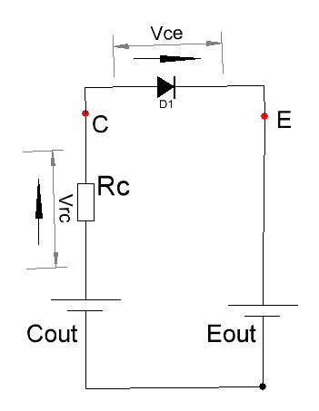
When measurement, the point E should be set to the minimum voltage, and then controls the voltage of the point C to rise slowly, and then measured the diode voltage and the current flowing through the diode.
The diode voltage is the value of Vce, the diode current is the current on RC, which means that we need to measure the value of Vce / Vrc and get the value of RC, and can be obtained of the VI characteristics of the diode.

Now, we explain the script every line.
Eout 2.5
Cout 2.5
"Eout2.5/Cout 2.5" set E channel output 2.5V and set C-channel output 2.5V. why should set to 2.5V, instead of 0V it?
Because the three channel programmable voltage generator is actually a power amplifiers, his structure is Darlington follower output.
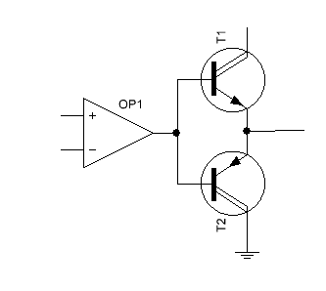
It can not only output current but also can sink current, When it sink current, The T2 voltage drop may be increase. Here we set to 2.5V is suitable. But some curve tracer on large curve, the voltage drop may increase to 3.5V.
SetRC 1
Statement "SetRC 1" select No 1 of RC range, here is 75ohm, at the same time the system will set system variables “CurrentRC” to 75.
WaitRelay
Statement "WaitRelay" is to wait for the relay stability, if measured immediately without waiting for the relay stability, the result will not reliable, “WaitRelay” statement waiting time is about 20ms.

Read the following script
for c=2.5 to 36 step 1
This statement generates a loop, the loop variable named ‘c’, the initial value is 2.5, the termination value is 36, the step size is incremented by 1.
Why the initial values ​​is 2.5? Becasue the E channel output is 2.5V, C-channel output must greater than or equal to the channel E. from 2.5V. Set Channel C initial value 2.5V mean at the beginning ,The voltage of diode is 2.5-2.5 = 0V.
Cout c
Set the the C channel output voltage, the voltage is equal to the variable ‘c’.
GetADC
Voltage measurements, after executed , the system variable “Vrc” and “Vce” value will be updated.
V=Vce
The system variable “Vce” is the voltage of diode, and save it to variable “V”.
I=Vrc/CurrentRC
Obtained by variable “Vrc” and “CurrentRC”, and calculation the current on RC,It also is the current of diode. And save it to variable “I”.
CurvePoint "D",V,I
Statement “CurvePoint” defined a point on a curve, His first parameter is the curve name, here is the "D"; The second parameter is the horizontal coordinate, here is the value of the variable “V”; The thirt parameters are the vertical coordinates, here is the value of the variable “I”.
Next
"NEXT" loop terminals statement, the program per execute this indicating the completion of a cycle, when the loop variable to be increased in a step value
EndCurve "D"
Statement "EndCurve" is end of a curve, and display the curve. His first parameter must be the same as the curve name of “CurvePoint” statement.
End
The end of the script.

From the above analysis to know, if we select different RC,we can measure different current range VI curve.
We also can change the value of the termination of the loop, and can get different current range, but due to the system hardware limits, the three channels maximum output voltage is probably only about 36V.

The following are examples of about FET Vds-Id curve.
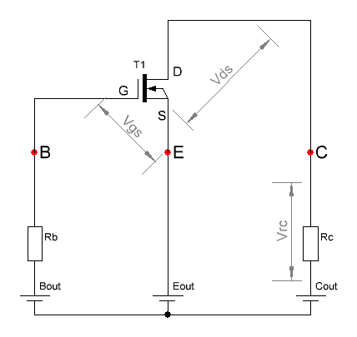
The Vds-Id curve is not a curve ,It is a cluster of curve. Its measurement process is fixed Vgs, then set Vds voltage from 0 to 36V, measured a Vds & Id, and draw a curve; and then increase the Vgs, and set Vds from 0 to 36V again, and draw another curve; and so on.
If you use the previous curve tracer software to measure a cluster of Vds-Id curve, for example, If a cluster have 10 curves, you need to manually set 10 times Vgs and click 10 times measure button. In Version 3.5, you can write a script to automated processing it.
From above measurement process, It need to produce two scanning voltage loop, a Vgs increments from 0 to 6V, and a Vds increments from 0 to 36V. In Vds incrementing process, Vgs must be constant. So the scripting process need two loop , a Vds increment loop need neste in Vgs loop.

Measurement script is as follows
Vbase=2.5
Cout Vbase
Bout Vbase
Eout Vbase
For convenience, here set a reference voltage “Vbase”. As the source (point E) for the reference voltage, Set E channel output to “Vbase”. All other channels are base on “Vbase”, for example, you want to set Vgs 3V, then you simply set the B-channel output for Vbase + 3V.
SetRB 1
SetRC 1
WaitRelay
The RB can be arbitrarily selected, but if the RB is too large, for example 1360K, then the high input impedance sensor external noise, and affecting the measurement results, so here selects Rb = 6K.
The RC select 75ohm (SetRC 1), The maximum drain current range is less than 36V/75ohm = 0.5A.
For Vg=0 to 6 step 0.5
The outer loop, the the Vg range from 0 to 6V, step 0.5V.
Bout Vbase+Vg
B channel output “Vg + Vbase”. Because the source voltage is “Vbase”, It means FET’s Vgs is equal “Vg”.
For Vd=0 to 36 step 1
The inner loop, Vd is the range of from 0 to 36V, step 1V.
Cout Vd+Vbase
The C channel output “Vd + Vbase”.
GetADC
Voltage measurements, after executed , the system variable “Vrc” and “Vce” value will be updated.
Vds=Vce
By the above figure, the D-S voltage is Vce.
Id=Vrc/CurrentRC
Drain current is same with the current on RC, Use system variable “Vrc” and “CurrentRC” to calculate the current of RC, and save to “Id”.
CurvePoint str(Vg), Vds, Id
Draw a point on the curve, a curve name must be string type, so it use function “Str(Vg)” to convert the numerical to string.
Each through the outer loop, Vg is changed, so the curve name have a new name. And so that it is easy to distinguish the different curves.
Next
Inner loop terminal statement, the program every perform here, the loop variable “Vd” increased by one step.
Cout Vbase
C channel Output ”Vbase”, It make the FET Vds voltage to 0, so that the next time measurement.
EndCurve str(Vg)
Draw the inner loop curve.
Next
Outer loop terminal statement, the program every perform here, the loop variable “Vg” increased by one step.
End
The end of the script

I use this script to measure IRF830, and get the image.
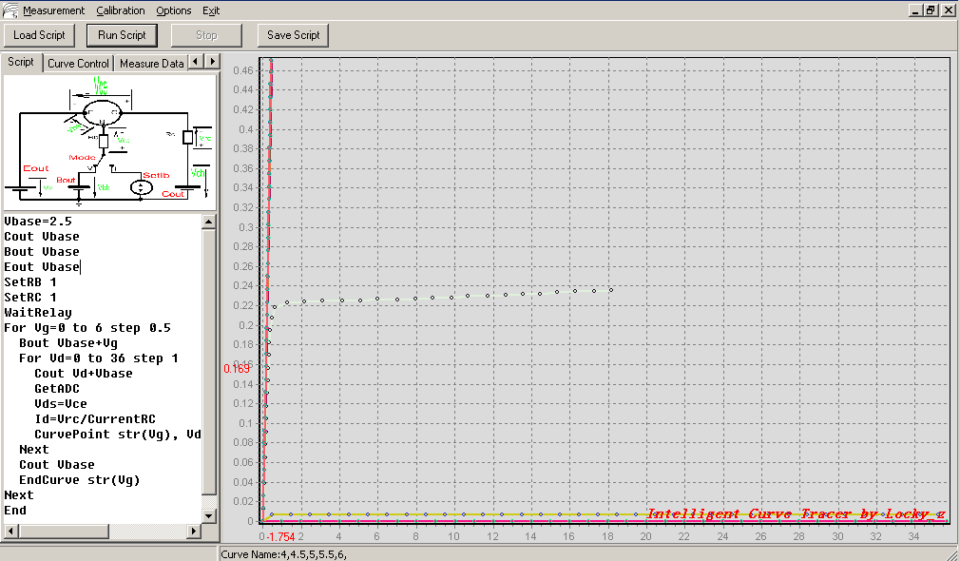
Now you can see only 2 to 3 curves, and near the X-axis coincides with a lot of curves, and near Y-axis also coincides with a lot of curves, why is it so?

This can be explained from the FET Vgs-ID curve.
I also measure the IRF830 Vgs-Id curve. The Y-axis of the figure is Id (mA), the X-axis is Vgs(V).
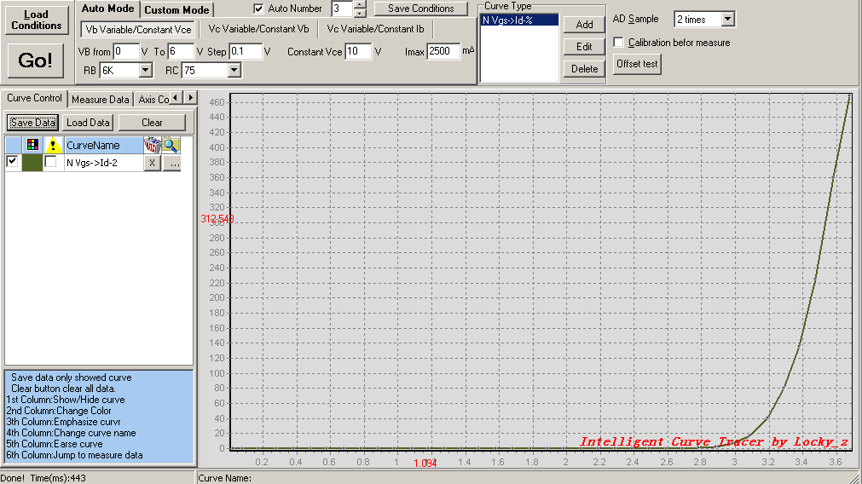
From the Figure, Vgs at 0 ~ 2.8V, the Id is very small, It almost coincident with X-axis. So in the Vds-Id curve figure, Their vertical coordinate is almost 0, and they are very close to the X-axis.
When Vgs from 2.8 to 3.6V, the current Id from 0 rapid increase to 460mA. If Vgs increases again, theoretically Id will continue to increase, but we selected RC = 75ohm, when Id = 460mA, The Vrc(Voltage drop on RC) is 0.46 * 75 = 34.5V. It has reached almost all the channel C output, and Vds get only a minimal voltage. So in the Vds-Id curve figure ,Vds approache to 0, mean they are close to the Y-axis, there are also a lot of curves overlap.
When Vgs = 2.8 ~ 3.6V range, you can see the real Vds-Id curve. But now, the Vgs step is 0.5V, So Vgs = 2.8 to 3.6V only have 1 to 2 curve will be displayed. If you want display 10 curves in range Vgs = 2.8 ~ 3.6V, You must set the step of Vgs to (3.6-2.8) / 10 = 0.08V.
But it will cause to produce 6/0.08 = 75 curves in the range of 0 ~ 6V, total, of which only 10 are effective, the other 86% of the curves is not much sense. That is to say 86% of the wastemeasuring time. So the best way is to set Vgs initial value is not 0. Then modify the script as follows, blue for the modified statement.

Vbase=2.5
Cout Vbase
Bout Vbase
Eout Vbase
SetRB 1
SetRC 1
WaitRelay
For Vg=2.5 to 4 step 0.08
Bout Vbase+Vg
For Vd=0 to 36 step 1
Cout Vd+Vbase
GetADC
Vds=Vce
Id=Vrc/CurrentRC
CurvePoint str(Vg), Vds, Id
Next
Cout Vbase
EndCurve str(Vg)
Next
End

This will display over 10 Vds-Id curve.
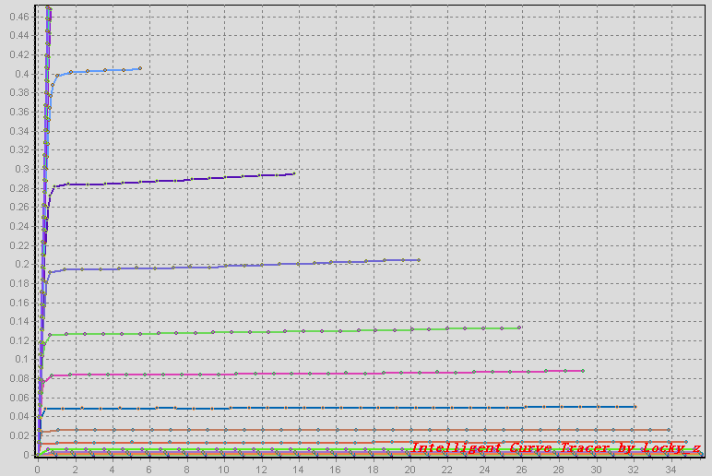
However, the above example is just for my IRF830. If your FET’s Vgs not this range, It is recommended that measure the “Vgs-Id” curve first. From the Vgs-Id curve, find out the Vgs range ,and change the Vds-Id script, modify the Vg initial value and termination value and the step value.
The tabulation show the functions and procedures, they are not case sensitive. Function need return a value, Procedures no value return., "[ ]" mean the optional parameters.
Procedures syntax | Description |  | Example
AxisLabel AxisType , ”label” | Define coordinates name | First parameter only one of the four characters ’UDLR’.  U mean upper horizontal coordinate;  D mean below horizontal coordinate;  L mean left of the vertical coordinate;  R mean right of the vertical coordinate.  The second parameter is coordinates name, It is string. | AxisLabel D, “Vce”  Define the below horizontal coordinate name is ‘Vce”.
AxisMin AxisType,value | Define the minimum of coordinate. | First parameter only one of the four characters ’UDLR’.  U mean upper horizontal coordinate;  D mean below horizontal coordinate;  L mean left of the vertical coordinate;  R mean right of the vertical coordinate.  The second parameter is coordinates min value, It is numeric. | AxisMin D,0  Define the coordinate begin from 0.
AxisMax AxisType,value | Define the maxmum of coordinate. | First parameter only one of the four characters ’UDLR’.  U mean upper horizontal coordinate;  D mean below horizontal coordinate;  L mean left of the vertical coordinate;  R mean right of the vertical coordinate.  The second parameter is coordinates max value, It is numeric. | AxisMax D,36  Define the coordinate end to 36.
Bout n | Set B channel output | After execute, B channel will outout ‘n’ voltage.  N must positive number. | Bout 10  Set B channel output 10V
Calibration | Do a calibration operation | System will control the calibration relay and do a calibration, and update the calibration parameter is PC memory, but not effect the parameter in EEPROM.
ClearCurve | Clear all the curve and data in table
Cout n | Set C channel output | After execute, C channel will outout ‘n’ voltage.  N must positive number. | Cout 10  Set C channel output 10V
CurvePoint CurveName,X,Y  [,n3[,n4[,n5[,n6  [,n7[n8[,n9]]]]]]] | Generate a point of data on curve, But the point not display until execute ‘EndCurve’ . | CurveName is the curve name, If the curve name exist, It will append the data to the curve.  X是horizotal value.  Y是vertical value.  The back of n3~n9 are option parameter, They will store into the 3~9 column tabulation. | Curve ‘Ic-Hfe’, Ic , Ic/Ib , Ve  Use the value of Ic and Ic/Ib to generate a point data on curve name “hfe-Ic”.  And the ‘VE’ value also write to 3th column in tabulation.
End | End of script.
EndCurve CurveName  [,color[,X-Axis[,Y-Axis]]] | Display the curveon screen and generate the data tabulation. | CurveName is curve name, It must use ‘CurveName’to generate first.  Coloris the curve color, it is a numeric, It is composition by RRGGBB, Example 256389 mean color is 25, green is 63, blue is 89, If missing this parameter, the curve color is random.  X-Axis control the curve use upper coordinate or below coordinate. D mean below coordinate, U mean upper coordinate. Default is below coordinate  Y-Axis control the curve use left coordinate or right coordinate. L mean left coordinate, R mean right coordinate. Default is left coordinate. | EndCurve ‘Ic-Hfe’  Display the curve ‘Ic-Hfe’.
Eout n | Set E channel output | After execute, E channel will outout ‘n’ voltage.  N must positive number. | Eout 10  Set E channel output 10V
ExitFor | Exit ‘for’ loop.
For VariableName = n1 to n2 [step n3] | Loop statement | First parameter is loop variable name.  Second pameter is the initialze loop variable value.  3th parameter is the end loop variablevalue.  4th parameter is step.  The maximum nesting is 24. | For Vb=2.5 to 12 step 0.5
GetADC [,n] | Do a AD convert, and store the result to system variable(VE/VCH/VBH/VBE/VCE/VRB/VRC) | Option parameter n is AD sample times  n=0~1 sample times=1  n=2 sample times=2  n=3~5 sample times=3  n=6~9 sample times=6  n=10~17 sample times=10  n=18~33 sample times=18  n=34~65 sample times=34  n>=66 sample times=66
GOSUB n | Call subroutine at linenumber is n. | The maximum nesting is 24.
Goto n | The program jumps to line number equ n to execute.
If … then | Conditional statement | The conditional only support numeric expression. | If (Ve<33) then goto 200
Init | Initialze B/C/E channel oupout and Set RB to3,Set RC to3. | The procedure will effect some relay and system variant(CurrentRB/CurrentRC).
Input Msg , variant | User input and store the value in variant. | Msg this parameter display the message.  Variant store user input. | Input “Please input the type” , $A
Mode I/V | Switch constant voltage/contant current mode | Parameter is I, mean switch to contant current,  V mean switch to normal mode(constant voltage).  This statement also will effect the relay. | Mode I  Set to constant current mode
MsgBox Msg | Display a window with some message. |  | MsgBox “please plug the compent”
Next | End of loop statement
Notice Msg | Display a message in statue bar. |  | Notice “Runing...”
REM [….] | Comment statements | After the ‘REM’ all the statement will be ignore.
Return | Subroutine return
SetIb i | Set the B channel output contant current. | I is mA, It is polarized.  It effect the relay and “CurrentRC” system variant. | SetIb -1  Set b channel output -1 mA
SetRB n | Select different RB type, N=0~3.  It will effec relay and system variant CurrentRB.t | RB=0 select 500ohm resistor  RB=1 select 6Kohm Resistor  RB=2 select 91K resistor  RB=3 select 1360K resistor | SelectRB 2  Select 91K resistor
SetRC n | Select different RC type, N=0~3.  It will effec relay and system variant CurrentRC.t | RC=0 select 4.55ohm resistor  RC=1 select 75ohm Resistor  RC=2 select 1K resistor  RC=3 select 12K resistor | SelectRC 2  Select 1K resistor
SetVce n | System auto adjust C-channel output so that make the Vce meet the setting value. | N is polarized.
StartWatch | Start the timer
WaitRelay | If the previous statement is effect relay, system will wait about 20ms to wait relay stability.
Function syntax | Description |  | Example
Abs(n) | Return the absolute value |  | Abs(-2)
Cos(n) | Return cosine value.
IsOnline() | determine whether tracer online? | If online then return 1 . If no online then return 0.
Ln(n) | return logarithm base e
Log(n) | Return logarithm base 10
Random(n) | Returns a random number between 0 ~ n
Sin(n) | Return sine value.
Sqrt(n) | Returns the square of n
StopWatch() | Returns the current value of the timer (ms).
Str(n) | Converted n into a string
Val(s) | Converted the string s to numberic value.

Script allows users to define variants, there are two type variants, one is numeric, one is a string, String variants must begin with $. Variant’s names up to 25 characters, no case sensitive, that mean abc and ABC are the same variant.
System allows up to 246 numeric type variants and 255 string type variants.
In the numerical variants, the system built in 9 system variant, you can read them but can not write. Their value change by system.
System Variant | Description
CurrentRB | Store the RB value, If execute SelectRB or SetIb, the CurrentRB will change.
CurrentRC | Store the RC value, If execute SelectRC, the CurrentRC will change.
Ve | Store the E channel voltage measurement value. Change by GetADC statement.
Vbe | Store the VBE voltage measurement value. Change by GetADC statement.
Vce | Store the VCE voltage measurement value. Change by GetADC statement.
Vrc | Store the VRC voltage measurement value. Change by GetADC statement.
Vrb | Store the VRB voltage measurement value. Change by GetADC statement.
Vch | Store the C channel voltage measurement value. Change by GetADC statement.
Vbh | Store the B channel voltage measurement value. Change by GetADC statement.

The system supports operators are:
+ - * /
% (Modulo number) ^ (power)
( )
+ Operator also be used to string type expression.

Line number must be numeric, and as a separate line, and only at the beginning of this line, the maximum length is 10 digits.

The maximum length of the script is 10k bytes.
4.Running parameter configuration
Main menu “Options->Config”
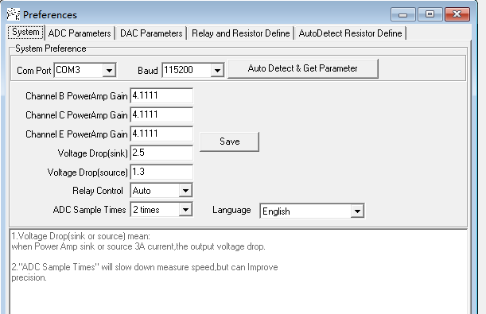
“Channel B/C/E PowerAmp Gain” is the gain of the three power amplifier channels,it is
56K/18K+1=4.1111.
“Voltage Drop(sink) parameter” is the minimum voltage drop of the power amplifier at the maximum sink current, generally 2.5V, but some curve tracer may be larger.
“Voltage Drop(source)” parameter is the voltage drop of the power amplifier at the maximum output current compared to the no-load maximum output, generally 0.5-1.5V.
“Relay Control” is the relay control mode, it is auto.
“ADC samples Times” is the ADC default sample times, default 2
“Language” Select the Chinese or English interface.

The “ADC parameter” parameter is already set at the factory. Generally no modification is required unless you have replace some of component on the board.
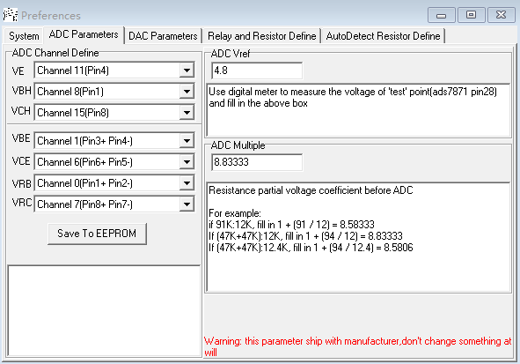
“ADC channel Define” don’t change,unless re-design PCB.
The ‘ADC Vref’ is ADC referent voltage. Use digital meter to measure the voltage of 'test' point( or ads7871 pin28) ON PCB. and fill in this field.
The “ADC multiple” is how many times the resistance is attenuated when connected to the ADC input. Some board is (47K+47K):12.4K, then the value is 94/12.4+1=8.5806;some board is (47K+47K):12K,then the value is 94/12+1=8.8333.
The old Version curve tracer is 91K:12K, then the value is 91/12+1=8.5833

The “DAC parameter”page is already set at the factory. Generally no modification is required unless you have replace some of component on the boar.
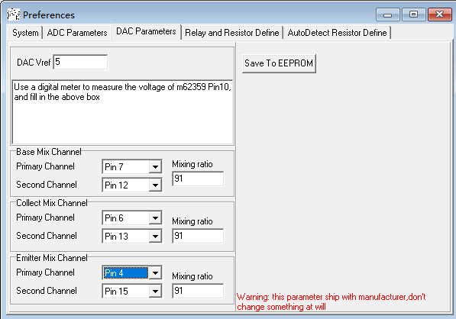
‘DAC Vref’ is DAC(M62359) referent voltage. Use a digital meter to measure the voltage of m62359 Pin10,and fill in the above box.
In these three group parameter ‘Base/Collect/Emitter’ Mix channel,the ‘primary/second’ channel number don’t change,unless re-design PCB.
The ‘Mixing ratio’ parameter is the mixing ratio of two DAC channels. It also is 1K:56K or 1K:91K, then set the value is 56 or 91.

The “Relay and Resistor Define” define the control bit, also not to modify.but the Value(OHM) can be change. If you replace another RB/RC resistor, then you need to modify these value.

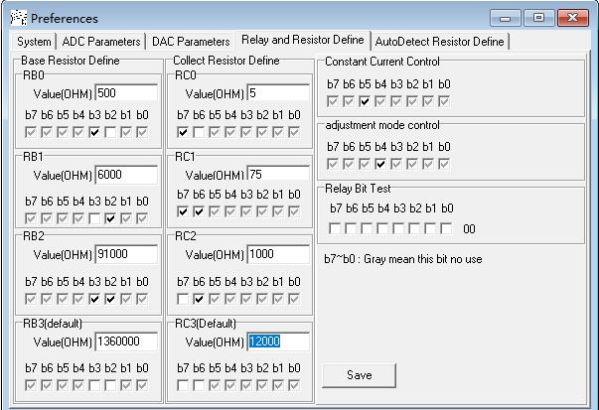

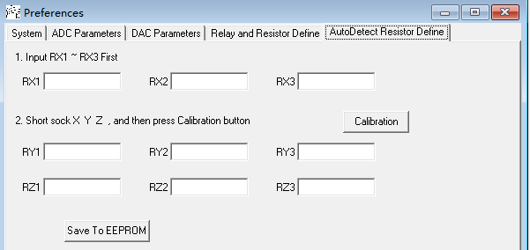
The ‘Autodetect Resistor define’ page is already set at the factory. Generally no modification is required.

All the “Save to EEPROM” need a password to write into eeprom,the password is ‘ct3’.

calibration
These calibration no need to do unless you replace some resistor on PCB or make a new board.
The calibration includes current and voltage calibration. Voltage calibration must be done first before run the current calibration.

I.Voltage calibration
Select Menu “Calibration -> Voltage Calibration”, click the “Begin calibration” button, the system will measure the data, and then click save to the EEPROM.
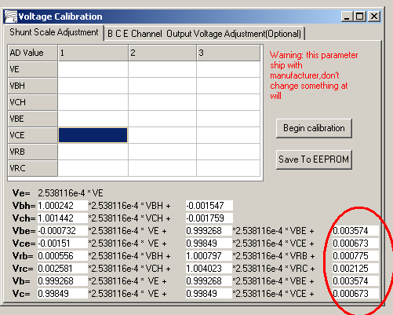

2. Select the page “BCE Channel Output Voltage Adjustment”
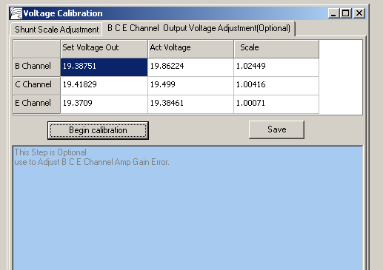
Click “Begin calibration”, the system will set the B/C/E channel amplifier output probably 1/2Vcc, and measure the actual voltage. On the table, the “Act Voltage” column shows the actual voltages measured by ADC. If the voltage is not close to 1/2Vcc, then, there might be some problem on the channel amplifier or DAC, also, the “scale” column values should be close to 1.
Click the “Save” button. The data is stored in the ini file.
After completed the Voltage calibration, you can perform the current calibration.

Current calibration
1. Calibration of each range resistor
Select the menu “Calibration-> the Current Calibration”
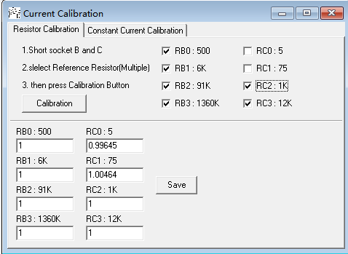

- Chose a or more reference resistor. The reference resistor is the most accurate resistors in those 8 resistor. For example, All RB and RC3 and RC2 is 1% metal film resistance, and RC1:75,RC0:5 is High Power Ceramic Resistors. It mean the RB0~RB3 and RC2 and RC3 is reference resistor, then checked them and remain RC0,RC1 not check.
- Use a wire connect soctet B and socket C ,
(3). Click “Calibration” button, system will auto set the coefficient of these RB0-RB3,RC2,RC3 to 1, and then, it will use RB0:500 to calibrate RC0 and RC1 coefficient.
The calibration diagram is as follows.
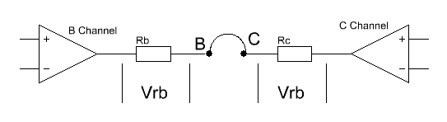
When click “calibration”, system will set B channel amplifier output a maximum voltage and C channel output minimum voltage. Because you use a wire short the scoket B & C, RB and RC is series, the current through them are the same. So it only need to measure the Vrb & Vrc value and know one of resistor value, then, system can calculate another resistor value.
(4) System will automatically control relay to select another resistor and calculate all the coefficient, and then click “Save”. The prameter are saved in ads7871_v3s.ini file.

2. B Channel constant current module calibration.
(1). Select “Constant Current Calibration” page.
(1). Use a wire to short socket B and socket C, click the “Calibration” button, the system will control the constant-current relay and switch to constant current mode, it will measure the coefficient of the constant current generator. Click “Save” to save data to the ads7871_v3s.ini file.

